**Hybrid Truck + Drone Delivery**

**1. Assumptions (Pandey):**

1) Truck and Drone move at constant speed

2) The flight path of a drone is a straight line, and the path length is expressed by Euclidean distance.

3) Infinite Drone Battery

4) The impact of the natural environment on drones is not considered

**Assumption (Hemant):**

● All customer demands are known before the start of operations and all customers must be served.

● Drones may be dispatched from the truck at the depot before the truck moves.

● The truck can only stop at depot locations to launch UAVs. ● When Drones are launched from the truck, they have to rendezvous with the truck at any of the subsequent stops along the route or at the depot.

● Drones can serve only a single customer request per dispatch. ● Drones can only serve requests that do not exceed their physical carrying capacity.

● Demand of each customer can be fulfilled by one visit of either the truck or a Drone.

● The flight range of the Drone is limited by time.

● When a Drone and the truck reconvene at a customer location, the one arriving earlier waits for the other.

● UAVs are recharged at the truck instantaneously.

● Multiple UAVs can be launched simultaneously.

● The return time to the depot is not considered in the objective value since we focus on minimizing the waiting time of the customers. **1. Assumptions (Saumya)**

● There is a set of potential stops from where the truck can launch or collect the drone.

● Customers are available during the time of the delivery, and each customer is visited only once.

● The fixed costs of the truck and drone are not taken into consideration, but their unit variable operating costs are.

● The number of deliveries per trip is limited by the load capacity of the drone. The drone is assumed to have a DL capacity in weight unit, where each customer has a demand of a single weight unit. ● The drone has a maximum flying range due to its limited battery.

**Assumptions (Khande)**

● There is only one parcel in the delivery task for each customer ● The waiting cost is not considered.

● A drone can carry at most one parcel

● The influence of parcels’ weight on drone endurance is ignored. ● Parcel - Small, light, one, normal

● Customer location - Simple

● Drones’ charging time is negligible

● Trucks can serve drones many times

**2. Decision Variables(Saumya):**

● Xijk Binary variable equals 1 if the drone moves from node i to node j in trip k and 0 otherwise.

● YijkBinary variable equals 1 if the truck moves from node i to node j to collect the drone, in which nodes i and j can be equal, in trip k and 0 otherwise.

● zijk Binary variable equals 1 if the truck moves from node i to node j to launch the drone in trip k and 0 otherwise.

● Tripk Binary variable equals 1 if the trip k is made and 0 otherwise. ● ujk Number of nodes visited by the drone from depot to node j in trip k ● l : Number of potential truck locations, indexed by i = 0, 1, …, l ● n : Number of customers nodes, indexed by j = l + 1, …, l + n

● Tij : Distance traveled by the truck between location i and j; i, j = 0, 1, …, l

● dij : Distance traveled by the drone between node i and j; i, j = 0, 1, …, n + l

● ɑD, ɑU : Unit variable cost for drone and truck, respectively. ● DL : Maximum number of customers visited by the drone in a single trip.

● R : Maximum drone’s fying range.

**Decision Variables (Hemant):**

**Parameters:**

● dij - Travel time between node i and j by truck

● tij - Travel time between node i and j by UAV

● L - Flight range limit of UAVs

● C - Number of customers

● K - Number of UAVs

**Sets:**

● V - Set of all nodes in the network. Elements 0 and c + 1 both represent the depot.

● C - Set of customers. C = { 1 , 2 , . . . , c } . | C | = c.

● C0 - Set of customers and the depot as the starting location. C0 = { 0 , 1 , 2 , . . . , c } .

● CE - Set of customers and the depot as the terminal location. CE = { 1 , 2 , . . . , c, c + 1 } .

● U - Set of UAVs. | U | = K.

**Indexes:**

● i, j, s, g, v, h Equivalently used indexes for the nodes of the network (customers and depot)

● u Index of UAVs

**Decision Variables:**

● xij - Binary variable; 1 if truck moves from node i to node j ; 0 otherwise.

● y u ijs - Binary variable; 1 if UAV u travels from node i to visit node j and returns to the truck at node s ; 0 otherwise.

● p ij Binary variable; 1 if node i is visited before node j by truck; 0 otherwise.

● z i Position of node i in the truck route

● t i Arrival time of truck at node i

● Li Departure time of truck from node i

● t iu Arrival time of UAV u at node i

● L iu Departure time of UAV u from node i

**3. Decision Variables (Pandey)(VRPD):**

**● Y**������: This binary variable equals 1 if the truck �� traverses the link (��, ��), and 0 otherwise. It essentially indicates whether the truck moves from node �� to node ��.

● **X**������: This binary variable equals 1 if drone �� ∈ �� traverses the link (��, ��) onboard of the vehicle, and 0 otherwise. It shows whether a drone travels along with the vehicle from node �� to node ��.

● **E**������: This binary variable equals 1 if drone �� ∈ �� dispatches from station �� ∈ ���� and collects from station �� ∈ ����, and 0 otherwise. It indicates whether a drone dispatches from one station and collects from another station.

● **F**����: This binary variable equals 1 if drone �� ∈ �� collected from station �� ∈ ���� by truck, and 0 otherwise. It signifies whether a drone collected from a station by the truck.

● **O**������: This binary variable equals 1 if drone �� ∈ �� stops at node �� ∈ ����, �� ∈ ℋ for serving, and 0 otherwise. It indicates whether a drone stops at a particular node for servicing.

● **Z**��������: This binary variable equals 1 if drone �� ∈ �� dispatched from station �� ∈ ���� travels on link (��, ��), �� ∈ ����, and 0 otherwise. It shows whether a drone dispatched from a station travels on a particular link.

● **θ**��: Time for arriving node �� ∈ ���� for drone �� ∈ ��. This parameter represents the time it takes for a drone to arrive at a particular node. ● **θ**��**′**: Time for leaving node �� ∈ ���� for drone �� ∈ ��. This parameter signifies the time at which a drone leaves a particular node.

● **ϕ**��: Time for arriving node �� ∈ ���� for truck ��. This parameter denotes the time it takes for the truck to arrive at a particular node.

● **ϕ**��**′**: Time for leaving node �� ∈ ���� for truck ��. This parameter indicates the time at which the truck leaves a particular node.

● ��: The earliest time to return to the depot. This parameter defines the earliest time by which the truck should return to the depot.

● ������: The weight of parcel that drone �� ∈ �� delivers to customer �� ∈ ����. This parameter specifies the weight of the parcel delivered by a drone to a customer.

**4. Decision Variables (Khande)**

● m: Indicator variable for trucks

● h: Indicator variable for drones

● i, j, k, n: Indicators of nodes, including customers and depots ● M: Total quantity of trucks

● H: Total quantity of drones

● N: Total quantity of nodes

● L: Total quantity of depots

● P: Total quantity of customers

● Tm: Driving range of the mth truck

● Dh: Flight range of the hth drone

● Tm: Driving distance of the mth truck

● Dh: Flight distance of the hth drone

● cT: Driving cost of trucks per unit of distance

● cD: Flight cost of drones per unit of distance

● dT: Total driving distance of trucks

● dD: Total flight distance of drones

● tmT: Task completion time of the mth truck

● thD: Task completion time of the hth drone

● tT: Total time consumption of trucks

● tD: Total time consumption of drones

**5. Applicable scenarios of the four delivery modes** ● Parallel delivery: The first delivery mode is generally used in cases where customers are densely distributed near the depots. Trucks and drones will not go to the same customer point.

● Mixed delivery: The second delivery mode is generally used in the case of large task scenarios and scattered customers. Generally, the routes of trucks and drones have intersections which are generally set on customer points. .

● Drone delivery with truck-assisting: The third delivery mode is generally used in the case of restricted terrain or blocked road network. In this case, trucks carry drones and parcels to some places near customer points, when trucks are unable to pass the road due to obstructions. Then, drones will load the parcels and deliver them to the customer points.

● Truck delivery with drone-assisting: The fourth delivery mode is generally used in the same day delivery. All orders on the same day have been known in advance, but due to time constraints or products that have not been made, trucks will deliver some parcels to customers first, and then drones will supply the trucks dynamically.

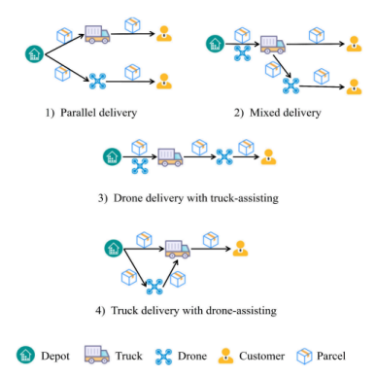

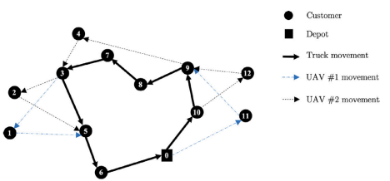

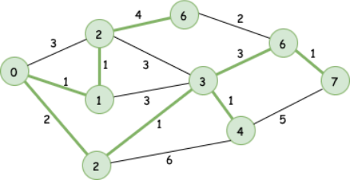

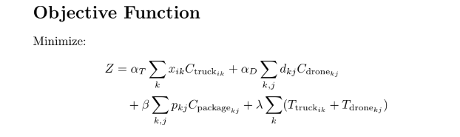

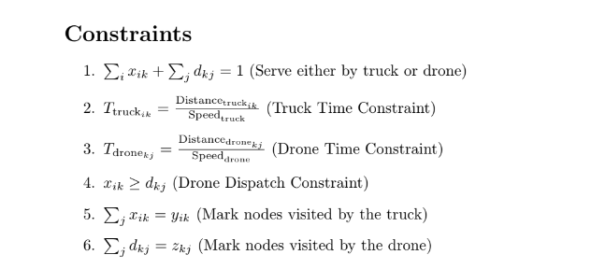

1. **Single Destination (Toy Problem)**

Using networkx library

Code link - <https://drive.google.com/file/d/1PuMmJ-MauqWBny3lryPW2c9L-8hKasyO/view?usp=sharing>

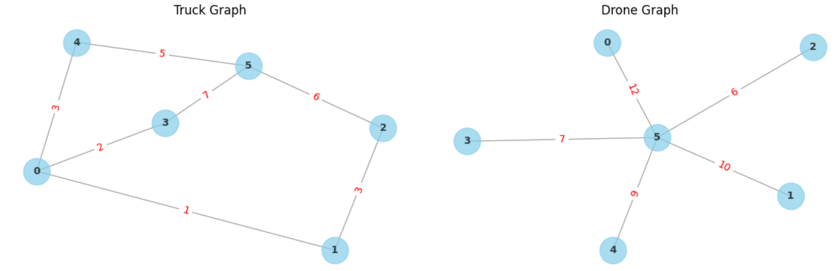

Output:   
 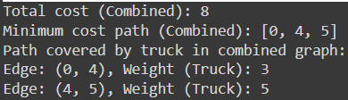

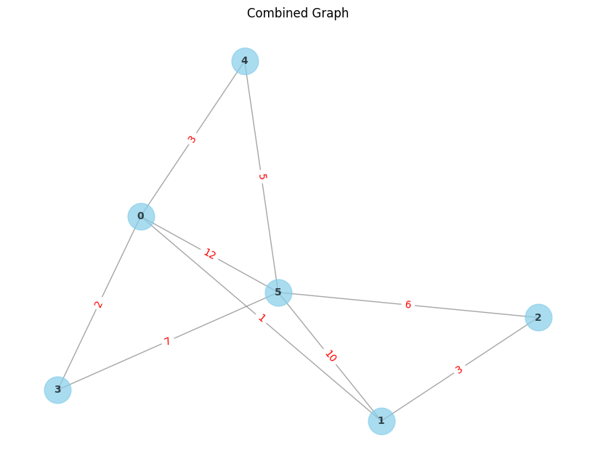

1. **Two Destinations:**

**Using Networkx**

**Colab link: https://drive.google.com/file/d/1bchSX5J_zm8wAbaFwQMiJh8CNm28byeb/view?usp=sharing**

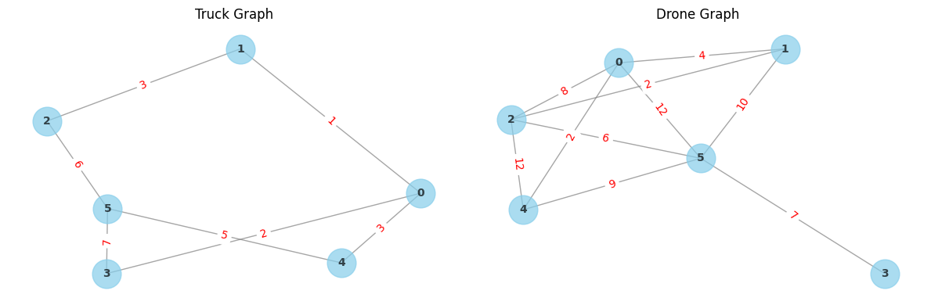

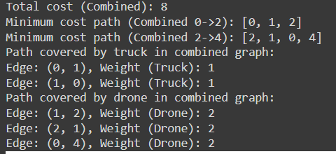

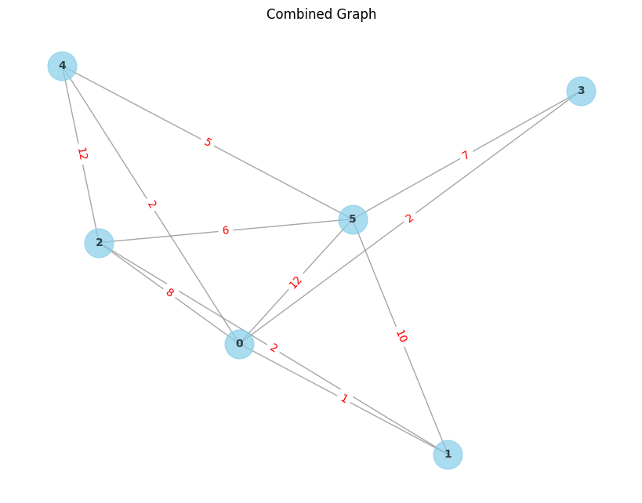

1. **Multiple Destinations**

**Using Networkx:**

**Link:** [**https://drive.google.com/file/d/1CFMeMs3uUXL3ecKpoQPlqEWdJlKDHP0S/view?usp=sharing**](https://drive.google.com/file/d/1CFMeMs3uUXL3ecKpoQPlqEWdJlKDHP0S/view?usp=sharing)

We have used permutations and combinations to calculate the cost of every path.  
  
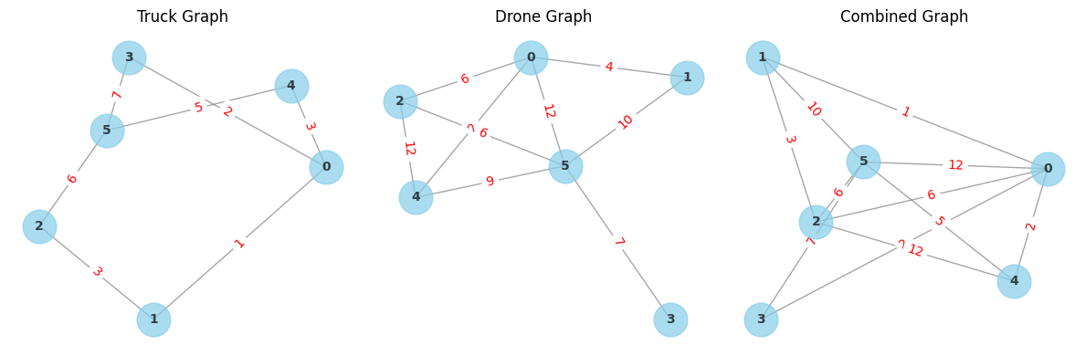

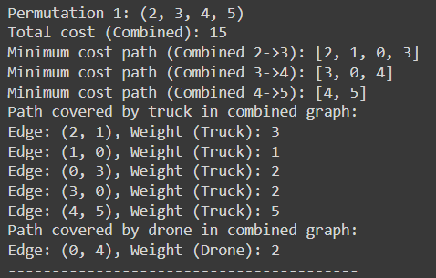

Optimal Combination:

Permutation 1 is the Optimal out of 24 PnCs  
  


1. **Using Gurobi Solver (still trying to debug the code)**

We are shifting our code from networkx to Gurobi. Because it was taking so much time for multiple destinations (for all PnC).

Link for .py file: https://drive.google.com/file/d/19Ej__1n0FuiSJ9FTflBIYBAn65v7xYqq/view?usp=sharing

